Shoot Like a Girl: Women in Wildlife Photography Symposium September 28, 2019 at the National Museum of Wildlife Art, Jackson, WY

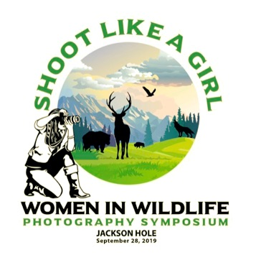

2019 Scholarship Application

Scholarship Application Deadline: Wednesday, September 11, 2019
The National Museum of Wildlife Art and Teton Photography Club, with generous support from Soroptomists International of Jackson Hole, is offering five scholarships for attendance at the Shoot Like a Girl one-day educational symposium on September 28, from 8:30AM to 4:30PM. These scholarships are available to female high school students in Wyoming and Teton County, Idaho who have an interest and experience in photography. The applicant’s photography experience does not need to be focused on wildlife or nature, but the applicant must demonstrate a serious interest in photography.
The scholarship covers the symposium registration fee ($100 value) and lunch for the scholarship winner. An accompanying adult chaperone will also be covered if desired ($100 value). The students must arrange their own transportation to the National Museum of Wildlife Art and local lodging if needed.
Shoot Like A Girl is a celebration of women wildlife photographers, their work, and their vision, hosted by the Teton Photography Club. The full day Symposium will be a day of education, storytelling, and inspiration. Prompted by the State of Wyoming’s 2019 “Year of Wyoming Women”, all presenters are women photographers who have drawn inspiration from the wilds and wildlife of the West and the Greater Yellowstone region. Each brings a unique expression to their photography as art or storytelling. Their presentations will demonstrate how to stretch creative vision, how photography can reveal wild lives and inspire change to benefit nature, and the ethics of wildlife photography.

Acclaimed conservation photographer Morgan Heim will be featured as Keynote Speaker. Ms. Heim’s work has appeared in Smithsonian, Newsweek, BBC, Discover and BioGraphic, with films in Telluride Mountain Film, Banff and Wild & Scenic festivals among others. She is a senior fellow with the International League of Conservation Photographers and has been recognized in the Wildlife Photographer of the Year and Big Picture Natural World competitions for her conservation photography. Heim will be joined by notable photographers including Fereshte Faustini, Jaymi Heimbuch, Kerry Singleton, Tenley Thompson, and Jantina Tuthill.

Attendees will learn how to expand their creativity in making wildlife images, see how wildlife photographers create images with impact and use multimedia to tell science and conservation stories, engage in panel discussions on craft and storytelling, and learn ethics for photographing wildlife in the wild.

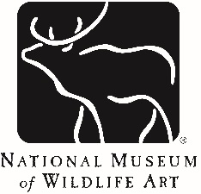

National Museum of Wildlife Art
2019 Shoot Like a Girl
Scholarship Application

Your application must be received by Wednesday, September 11, 2019

Name: _________________________________ Grade Level: ____________

School: _________________________________

Mailing Address: ______________________________________________________

Phone: (____)______________ Email address: ___________________________

Parent or guardian phone and email: _______________________________________

Please complete the following questions. Please keep application to two pages max plus supplemental materials.

1. Describe why you are seeking a Shoot Like a Girl scholarship. How would this symposium contribute to your education and future professional goals?

2. Describe your background in photography. List any previous photography-related classes or workshops you have taken or other structured photography activities (e.g., yearbook) along with the course title, location, and year.

3. A professional letter of recommendation from someone who can speak to your interest in photography and your work ethic is recommended, but not required. The letter may be emailed separately (email subject line should be SLAG application letter: your name). Indicate here whom you have asked to write on your behalf.

4. Please include a minimum of three, maximum of five digital examples of past photography work. Attach image files with your email application. Images must be 72ppi and in JPEG format.

Applicant’s Signature: _____________________________ Date: ______________________

Parent/Guardian’s Signature: _________________________ Date:_______________________

*Guardian please note: If accepted, student will need transportation to and from the NMWA for the symposium, and accommodation in Jackson, WY area. One adult guardian/chaperone may accompany the student at the symposium. The entry fee and lunch will be covered by the scholarship for the student and chaperone.

We will notify you by Friday, September 13th. Please return your completed application by email, with SLAG application: your name in subject line, to:

Lisa Simmons, Associate Curator of Education and Outreach: lsimmons@wildlifeart.org | 307-732-5435

